HOSPICE AFRICA LIMITED  Report of the Directors & Trustees  for the year ended 31st March 2025 | 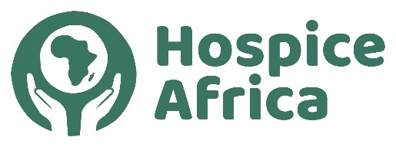

Contents
Legal & Administrative Information 1
Governance & Management 1
Hospice Africa Origins 2
Fundraising 3
Hospice Africa Uganda 4
Volunteers travelling to Uganda 4
Finance & Governance Risks 5
Audited Accounts 2024-25 Separate Document File

Legal and administrative information

Company number:  Registered in England No. 02835469 | Registered charity number:  Charity Commission No. 1024903

Directors and Trustees at  Mr Chris Merriman (Hon. Chair)  Ms Pat Linnell (Hon. Treasurer)  Dr Mary Bunn (Hon. Secretary)  Prof Anne Merriman (Founder) MBE  Mr Doug Haynes | 31st March 2025  Ms Hannah Merriman  Dr Philippa Guppy  Mr Will Peachey  Mrs Emma Matthews (appointed 10/02/25  Dr Kate Eldred (appointed 10/02/25)  Dr Catherine Merriman (resigned 20/07/24)

Hon. Company Secretary: Dr. Mary Bunn | Independent Examiner:
Registered Office:  Holly Bank, 34 Altys Lane,  Ormskirk. L39 4RQ | Butterworth Barlow Accountants  Prescot  Merseyside L34 3LG
REPORT OF THE DIRECTORS AND TRUSTEES

The Trustees, who are also the Directors of the charity for the purposes of the Companies Act, present their annual report and the financial statements for the year ended 31 March 2025. The Trustees have adopted the provisions of the Statement of Recommended Practice (SORP 2005) "Accounting and Reporting by Charities" in preparing the annual report and financial statements of the charity.

The Annual General Meeting (AGM) 2025 is scheduled to be on-line on Sunday 26th October 2025 at 2.30pm.

www.hospice-africa.org/uk is the Hospice Africa website covering HA work in the UK.

Nomenclature:
- Hospice Africa Ltd is a Limited Co. and Charity located in the UK. (HAUK)
- Hospice Africa Uganda (HAU) is a non-governmental organization and a limited company registered in Uganda.
- Hospice Africa (HA) sometimes refers to the overall work of Hospice Africa.

Structure, Governance and Management

The charity is constituted as a company limited by guarantee, governed by a memorandum and articles of association. The charity’s object and principal activity continues to be ‘to support the provision of palliative care to terminally ill cancer and AIDS patients and their families in Africa’.

The Trustees have continued to meet regularly to manage the affairs of the charity in the UK. During the 2024-25 year, the platform used has transferred from zoom to Google Meet. It has continued to be an efficient communication platform enabling Trustees Dr. Anne Merriman and Dr. Mary Bunn to attend Trustees meetings from their African bases!

We are grateful to Frank Cottrell-Boyce who has kindly continued to act as a Patron for Hospice Africa.

The charity’s work continues to be carried out entirely on a voluntary basis. The Hon. Treasurer manages the day-to-day finances of the charity. The Hon. Chair, Hon. Secretary and Hon. Treasurer, with help from other Trustees, have shared the collective duties normally carried out by a Chief Executive. The Board of Trustees has the power to appoint additional Trustees as it sees fit within the remit of the Articles of Association. There are no employees within the charity.

The work is carried out in close partnership with the Founder, Professor Dr. Anne Merriman, and there is regular contact with Hospice Africa Uganda Management Team (HAU), which is a non-governmental organization and a limited company in Uganda. An umbrella network ‘The Hospice Africa Foundation’, including the Founder, provides experienced governance, perspective, and protection of the HA Ethos.

There is an AGM at the end of October when Trustees, donors, supporters and charity shop staff can meet on-line. The link is available from anywhere globally, but particularly provides links for Trustees and supporters who are located in Africa.

Hospice Africa Origins

Hospice Africa was founded in 1993 to spread the ethos and practice of palliative care in Africa. Our founder, Dr. Anne Merriman, has radically changed the provision of care and pain relief for people in Africa with life-limiting illnesses. 'This has transformed the lives of thousands of patients, improving quality of life for many with holistic care and symptom relief, and supporting patients to have a comfortable and dignified death.' Hospice Africa UK raises and manages funds in the UK to send to our partners in Africa, and particularly focused towards Hospice Africa Uganda (HAU). With our African partners, we have helped to introduce palliative care to 35 African countries. In 20 of these 35 countries, affordable oral morphine, the backbone of all palliative care, is now available for pain relief.
Dr. Anne Merriman – 90th Birthday

Dr. Anne reports, as she approaches her 90th birthday, that although she has been seriously unwell for several phases in the last year, she has ‘bounced back’ and tried to remain active. She has been very appreciative of various volunteers from the UK giving practical and moral support on their extended visits, particularly Drs Kate and Ollie, and Dr. Helena.

Anne has reminded us that hospitum means hospitality or a place of rest and protection for the ill and weary. Hospice Africa are forever grateful for the collaborative care that partners offer to our patients and the people of Uganda.  As ever, Dr. Anne would like to thank all supporters for their love, support and prayers over the last year. “We are so grateful to be able to continue the work we do at hospice, but sometimes it seems that the need is endless!” | 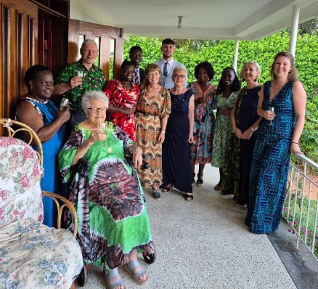

Fundraising

Over 50% of the charity’s income is provided by individual (gift-aided) donations, and we are extremely grateful to a large number of dedicated supporters.

The two charity shops in Liverpool and Ainsdale continue to provide vital funds for the palliative care work in Africa. The Ainsdale shop, where there has been a revamp and upgrade, has been through a phase of evaluating opening times and shop management. We continue to be grateful to our volunteer shop managers (Ann and Liz at Old Swan, and Shelley and Jane at Ainsdale (until Dec 2024) and Siobhan (in 2025) who have carried a busy workload to keep the shops running effectively, and also to the dedication of all the shop volunteers. We again give our thanks to Maria Merriman who has continued to work with the volunteer managers and staff at the Ainsdale Shop over the last two years.
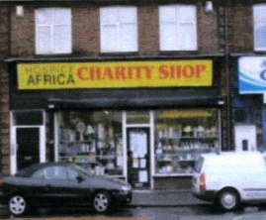 | 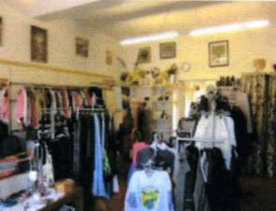 | 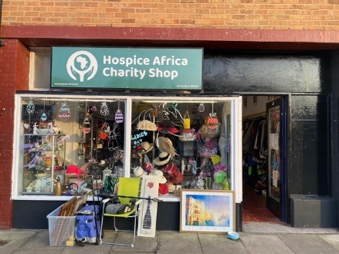
Liverpool Old Swan Shop Ainsdale Shop

The Big Give Campaign: Trustee, Dr. Philippa Guppy, has again been enthusiastic in pursuing the opportunity to match-fund a large proportion of the donations within a ‘Big Give’ week last Autumn. We have again set our hopes high, and it has paid off. The total kept rising, finally reaching £25,695. Thank you all so much.

Hospice Africa Uganda (HAU)

The team in Kampala, who regard themselves as a Hospice Africa Family, continue to ensure the provision of specialist palliative care services under the leadership of their Chief Executive, Prossy Nakyanja, and their Uganda Board. They are grateful to their partners and donors for the unwavering support. During the last year, they have continued to operate within strict budget limitations being enforced , so it continues to be an ongoing struggle to ensure the delivery of sustainable palliative care services.

Mbarara – Completion of MHM Building Renovation Project nearing completion

The renovation of the Mbarara site, initiated by a generous legacy donation, has been an ongoing marathon. Project managed by Antonia Kamate, with the structural works completed, there remained a need to build up operational stocks including a medical tent, two patient beds, four desktop computers, and various items of medical equipment.
Volunteers Travelling to Uganda

Dr Helena Spriggs, a palliative medicine registrar, based in the NE of England, has been volunteering with Hospice Africa in Uganda for the early part of 2025. Her review, before returning to the UK, has been very incisive, and provided several positive improvement recommendations which have been well received at HAU. | 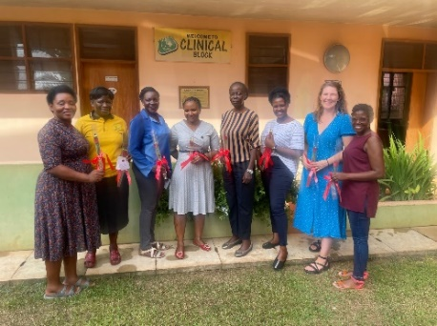
Brief Financial Review

The Hospice Africa Limited Annual Accounts 2024-25 are being presented as a separate document and file. This section relates to the Annual Accounts.

 | 23-24 | 24-25
Income | £210,803 | £199,460 | decrease
Expenditure | £277,503 | £213,444 | decrease

Last year, the expenditure exceeded income by £14,000 resulting in our reserves reducing from £224,152 to £210,168.

Charitable activities amounted to £189,196 supporting work primarily in Uganda and Malawi. They also support the development of palliative care clinicians from other African countries through the educational programmes run by HAU’s Institute (Institute of Hospice and Palliative Care in Africa) and the International Programmes Team.

The Board of HAU has continued to manage the running costs with care, but there still remains a challenging funding shortfall in Uganda. There have been regular on-line meetings between the UK Chair and UK Treasurer and HAU senior staff aimed at evaluating the ongoing deficit and trying to ensure that Hospice Africa Ltd can continue to regulate its income, reserves, and budgeted funding to HAU to ensure that HAU remains solvent both in the 2025-26 period and in the immediate years ahead.

Funding Risks

Because the Charity employs no staff, except on a voluntary basis, all of the income raised, apart for a small amount of governance expenditure, is used directly for the work of the Charity in its core objective of palliative care for the African continent. The probity exercised by UK Trustees is to convert the funds already raised in the UK to become available to send to Uganda.

Trustees are aware that there was still a two-fold risk, as the Hospice Africa organisation steered through a difficult year.

- an on-going deficit in Uganda: the HAU Board must bring operations out of deficit.
- a likely reduction in funds available in the UK: this is already challenging HA Limited to exercise probity in its UK support to HAU.

HA UK Trustees will continue, as far as possible, to ensure the enduring vision of palliative care for all in need in Africa continues.

Independent Examiner

Butterworth Barlow Accountants (Prescot) are acting as our Independent Examiners.

This report was approved by the Board of Directors and Trustees on August 4th 2025 and signed by  the Hon. Chair, Chris Merriman | 

Addendum: Dr. Anne’s Passing (from an Obituary in the Irish Times)

Dr. Anne Merriman born 13th May 1935  died 18th May 2025  Dr. Anne Merriman, a visionary humanitarian who introduced palliative care to Uganda and much of Africa, has died at the age of 90. Widely regarded as “the mother of palliative care in Africa”, she founded Hospice Africa Uganda (HAU) in 1993 to bring affordable, holistic, compassionate care to people suffering from critical and life-limiting illnesses. | 