HOSPICE AFRICA LIMITED  Report of the Directors & Trustees  for the year ended 31st March 2024 | 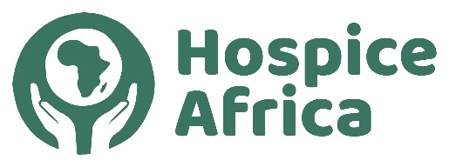

Contents
Legal & Administrative Information 1
Governance & Management 2
Hospice Africa Origins 2
Fundraising 3
Hospice Africa Uganda 4
Volunteers travelling to Uganda 5
Finance & Governance Risks 5
Audited Accounts A1 - A7

Legal and administrative information

Company number:  Registered in England No. 02835469 | Registered charity number:  Charity Commission No. 1024903

Directors and Trustees at  Mr Chris Merriman (Hon. Chair)  Ms Pat Linnell (Hon. Treasurer)  Dr Mary Bunn (Hon. Secretary)  Prof Anne Merriman (Founder) MBE  Mr Doug Haynes | 31st March 2023  Ms Hannah Merriman  Dr Philippa Guppy  Mr Will Peachey  Dr Catherine Merriman

Company Secretary: Dr. Mary Bunn | Independent Examiner:
Registered Office:  Holly Bank, 34 Altys Lane,  Ormskirk. L39 4RQ | Butterworth Barlow Accountants  Prescot  Merseyside L34 3LG
REPORT OF THE DIRECTORS AND TRUSTEES

The Trustees, who are also the Directors of the charity for the purposes of the Companies Act, present their annual report and the financial statements for the year ended 31 March 2024. The Trustees have adopted the provisions of the Statement of Recommended Practice (SORP 2005) "Accounting and Reporting by Charities" in preparing the annual report and financial statements of the charity.

The Annual General Meeting (AGM) 2024 is scheduled to be on-line (Zoom) on Sunday 13th October 2024 at 2.30pm.

Nomenclature:
- Hospice Africa Ltd is a Limited Co. and Charity located in the UK. (HAUK)
- Hospice Africa Uganda (HAU) is a non-governmental organization and a limited company registered in Uganda.
- Hospice Africa (HA) sometimes refers to the overall work of Hospice Africa.

www.hospice-africa.org/uk is the Hospice Africa website covering HA work in the UK.

Structure, Governance and Management

The charity is constituted as a company limited by guarantee, governed by a memorandum and articles of association. The charity’s object and principal activity continues to be “to support the provision of palliative care to terminally ill cancer and AIDS patients and their families in Africa”.

The Trustees have continued to meet regularly to manage the affairs of the charity in the UK. The zoom platform has continued to be an efficient communication platform enabling Trustees Dr. Anne Merriman and Dr. Mary Bunn to attend Trustees meetings from their African bases!

We are grateful to Canon Dr. Donald Gray and Frank Cottrell-Boyce who have kindly continued to act as Patrons for Hospice Africa.

The charity’s work continues to be carried out entirely on a voluntary basis. The Hon. Treasurer manages the day-to-day finances of the charity. The Hon. Chair, Hon. Secretary and Hon. Treasurer, with help from other Trustees, have shared the collective duties normally carried out by a Chief Executive. The Board of Trustees has the power to appoint additional Trustees as it sees fit within the remit of the Articles of Association.

The work is carried out in close partnership with the Founder, Professor Dr. Anne Merriman, and there is regular contact with Hospice Africa Uganda (HAU), which is a non-governmental organization and a limited company in Uganda. There is an AGM at the end of October when trustees, donors, supporters and charity shop staff meet at the Brain Charity Centre in Liverpool, with a zoom on-line link available from anywhere globally, but particularly providing links for Trustees and supporters located in Africa.

Hospice Africa Origins

Hospice Africa (HA) was founded in 1993 to spread the ethos and practice of palliative care in Africa. Our founder, Dr. Anne Merriman, has radically changed the provision of care and pain relief for people in Africa with life-limiting illnesses. 'This has transformed the lives of thousands of patients, improving quality of life for many with holistic care and symptom relief, and supporting patients to have a comfortable and dignified death.'

Hospice Africa raises and manages funds in the UK to send to our partners in Africa, particularly in the long-term with Hospice Africa Uganda (HAU). With our partners, we have helped to introduce palliative care to 35 Africa countries. In 20 of these 35 countries, affordable oral morphine, the backbone of all palliative care, is now available for pain relief.

Dr. Anne Merriman – Autobiography – ‘That’s How the Light Got in’

Dr. Anne reports, as she approaches her 89th birthday, that she is in fairly good health after two difficult years health-wise. Her new book is available on Amazon.  Anne writes …  I would like to thank you for your love, support and prayers, over the last year. We are so grateful to continue the work we do at hospice, but the need is endless. We are so grateful for your continued support and love; we truly feel it! | 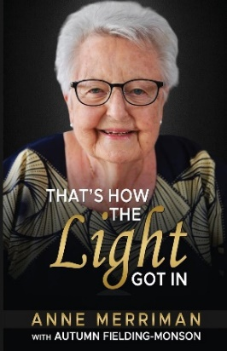
Fundraising

At Hospice Africa UK, we have managed to stay positive and motivated with our vision for ‘palliative care across Africa central to all that we do’. The governance integrity of the charity revolves around raising funds through two charity shops, regular gift-aid funding from personal contributions, and fund-raising initiatives. Where possible, we have been able to gain grants, but it appears that grant funding is more effectively secured when the grant applications are sourced from our operational partners in Africa. We send annual restricted and unrestricted budgeted funds of some £260,000 to Africa in line with the funding intentions.

Over 50% of the charity’s income is provided by individual (gift-aided) donations, and we are extremely grateful to a large number of dedicated supporters.

The two charity shops in Liverpool and Ainsdale are providing vital funds for the palliative care work in Africa. In the Liverpool shop, the annual gross income was £49,642, and in the Ainsdale shop, where there has been a revamp and upgrade, the annual gross income was some £43,323. We continue to be grateful to our volunteer shop managers (Ann and Liz at Old Swan and Shelley and Jane at Ainsdale) who carry a busy workload to keep the shops running effectively, and also to the dedication of all the shop volunteers. We also give grateful thanks to Maria Merriman who has worked with the volunteer managers and staff at the Ainsdale Shop during the upgrade.
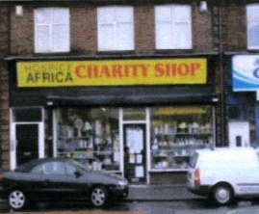 | 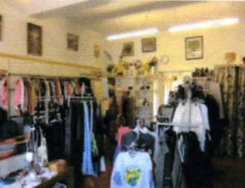 | 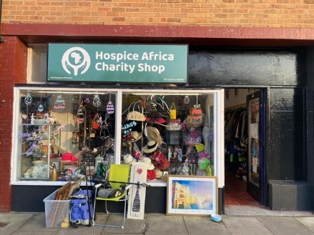
Liverpool Old Swan Shop Ainsdale Shop

The Big Give Campaign: Trustee, Philippa Guppy, has been enthusiastic in pursuing the opportunity to match-fund a large proportion of the donations within a ‘Big Give’ week last Autumn. We set our hopes high, and it paid off. The total raised kept mounting, finally reaching £22,491. Thank you all so much.

Hospice Africa - 30 Year Celebrations

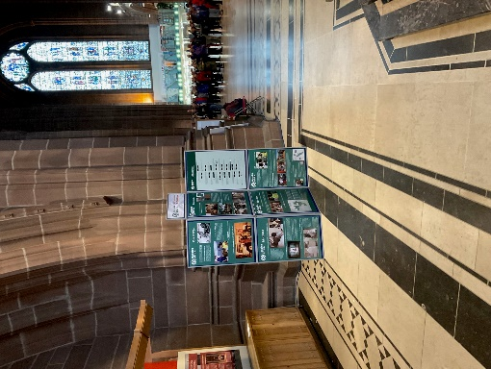 |   Evensong  in thanksgiving for  30 years of  Hospice Africa  Friday 22nd September 2023 | 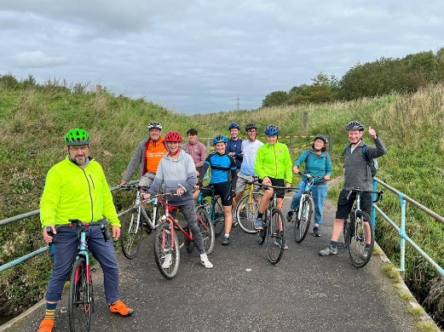
30th Anniversary Exhibition in Liverpool Anglican Cathedral | Evensong Brochure | 30th Anniversary Cycle Ride  from the Ainsdale shop  to the Old Swan Shop

Hospice Africa Uganda

The team in Kampala continue to ensure the provision of specialist palliative care services. They are so grateful to the Hospice Africa Family, their Uganda Board, and their partners and donors for the unwavering support. During the last year, they have had to operate within strict budget limitations, so it continues to be an ongoing struggle to ensure that the delivery of palliative care services remains viable and sustainable.

An overview of the Hospice Africa work in Uganda is summarised in the Hospice Africa Uganda section of the Website shown below. (www.hospice-africa.org)

Clinical Care | Education | International  Programmes | Morphine  Production
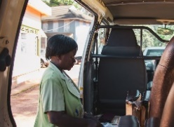 | 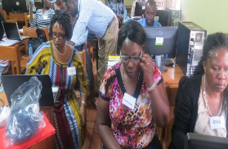 | 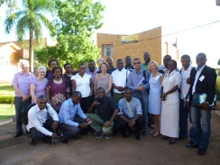 | 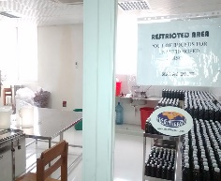
Our clinical teams  treat patients,  providing them with  holistic palliative  care from within the  clinic or at their  homes. They work  from three sites …  Kampala, Hoima  and Mbarara. | A core part of our  mission is to enable  palliative care across  Africa. We do this by  providing training for  students and health-  care professionals  from across the  continent. | Although our clinical  centre is in Uganda,  we work with partner  organisations in  many African  countries to  promote palliative  care across the  continent. | Hospice Africa produces affordable morphine on-site in Kampala which is then prescribed to our patients and send out to other medical facilities across the country.
Volunteers Travelling to Uganda

 | 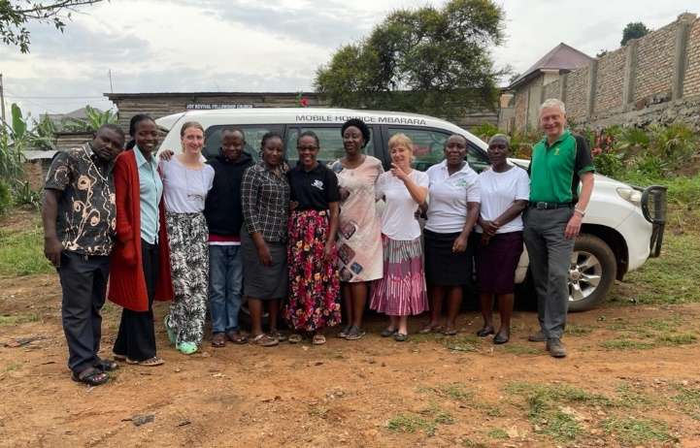
Chris and Maria Merriman visiting  HAU (July 2023) | Drs Ollie and Kate Sykes visiting  HAU - Mbarara (Jan-March 2024)

Our UK Board Chair Chris Merriman and his wife Maria visited Hospice Africa Uganda for two weeks at the beginning of July and had an unforgettable experience. They received the warmest of welcomes both from Dr Anne’s family household and also the HAU teams at the Kampala, Mbarara and Hoima sites. Chris and Maria were so pleased to spend precious time with Dr Anne, and also had a very full itinerary of meetings with hospice leadership, team members, partner organisations, and local supporters.
Most importantly they joined the clinical teams on patient home visits from all three hospice sites and saw again at first hand the extraordinary palliative care service that HAU delivers every day with incredible expertise, love and compassion, leaving no stone unturned in their mission to address all the needs of the patient and their family.

Chris commented that “We were blown away by the commitment and dedication of all the HAU team, and it’s very clear how much they appreciate all of the support they receive from HAUK and our donors. The money we send over to Uganda is put to excellent use.”

Give a Chance

Hannah Merriman oversees the ‘Give a Chance’ programme where children of HAU patients have been offered support for their schooling on an ongoing basis. This is a relatively small programme supported by a small number of enthusiastic donors who provide ‘committed’ donations.

Brief Financial Review

The charity’s income has decreased from £298,435 last year to £210,803 during 2023-24 with resources expended increasing from £186,035 to £277,503.
The expenditure exceeds income by £66,700 resulting in our reserves reducing from £290,852 to £224,152.

Charitable activities amounted to £245,013 supporting work primarily in Uganda and Malawi. They also support the development of palliative care clinicians from other African countries through the educational programmes run by HAU’s Institute (Institute of Hospice and Palliative Care in Africa).

The Board of HAU has continued to manage the running costs with care, but there still remains a challenging funding shortfall in Uganda. There have been regular on-line meetings between the UK Chair and UK Treasurer and HAU senior staff aimed at evaluating the ongoing deficit and trying to ensure that Hospice Africa Ltd can continue to regulate its income, reserves, and budgeted funding to HAU to ensure that HAU remains solvent both in the 2023-24 period and in the immediate years ahead.

Funding Risks

Because the Charity employs no staff, except on a voluntary basis, all of the income raised, apart for a small amount of governance expenditure, is used directly for the work of the Charity in its core objective of palliative care for the African continent. The probity exercised by UK Trustees is to convert the funds already raised in the UK to become available to send to Uganda.

Trustees are aware that there was still a two-fold risk, as the Hospice Africa organisation steered through a difficult year.

- an on-going deficit in Uganda: the HAU Board must bring operations out of deficit.
- a likely reduction in funds available in the UK: this is already challenging HA Limited to exercise probity in its UK support to HAU.

HA UK Trustees will continue, as far as possible, to ensure the enduring vision of palliative care for all in need in Africa continues.

Auditor and Independent Examiner

Butterworth Barlow Accountants (Prescot) are acting in their first year as our Independent Examiners.

This report was approved by the Board of Directors and Trustees on 12th August 2024 and signed by  the Hon. Chair, Chris Merriman | 

