HOSPICE AFRICA LIMITED  Report of the Directors & Trustees  for the year ended 31st March 2023 | 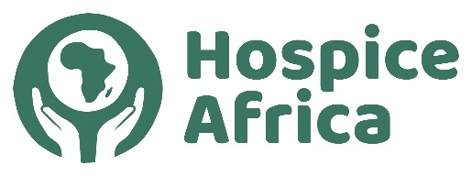

Contents
Legal & Administrative Information 1
Governance & Management – Trustee News 2
Hospice Africa Origins 3
Fundraising 3
Hospice Africa Uganda 4
Finance & Governance Risks 5
Audited Accounts A1 - A7

Legal and administrative information

Company number:  Registered in England No. 02835469 | Registered charity number:  Charity Commission No. 1024903

Directors and Trustees at  Mr Chris Merriman (Hon. Chair)  Ms Pat Linnell (Hon. Treasurer)  Dr Mary Bunn (Hon. Secretary)  Prof Anne Merriman (Founder) MBE  Mr Doug Haynes | 31st March 2023  Ms Hannah Merriman  Dr Philippa Guppy  Mr Will Peachey (app. 17th May 2022)  Dr Catherine Merriman (app. 9th Jan. 2023)

Company Secretary: Dr. Mary Bunn | Independent Examiner: Roger Hughes
Registered Office:  Holly Bank, 34 Altys Lane,  Ormskirk. L39 4RQ | Lower Farm  90 Brimstage Road, Heswall,  Wirral. CH60 1XQ

REPORT OF THE DIRECTORS AND TRUSTEES

The Trustees, who are also the Directors of the charity for the purposes of the Companies Act, present their annual report and the financial statements for the year ended 31 March 2023. The Trustees have adopted the provisions of the Statement of Recommended Practice (SORP 2005) "Accounting and Reporting by Charities" in preparing the annual report and financial statements of the charity.

The Annual General Meeting (AGM) 2023 is scheduled to be in person at The Brain Centre (Norton St, Liverpool L3 8LR) on Sunday 24th September 2023 at 1.30pm. We are hoping to facilitate an on-line link for trustees and supporters to join remotely.

Nomenclature:
In this report, Hospice Africa Ltd is a Limited Company and Charity in the UK.
Hospice Africa Uganda (HAU) is a non-governmental organization and a limited company registered in Uganda.
Hospice Africa (HA) sometimes refers to the overall work of Hospice Africa.

www.hospice-africa.org/uk is the Hospice Africa website covering HA work in the UK.

Structure, Governance and Management

The charity is constituted as a company limited by guarantee, governed by a memorandum and articles of association. The charity’s object and principal activity continues to be “to support the provision of palliative care to terminally ill cancer and AIDS patients and their families in Africa”.

The Trustees have continued to meet regularly to manage the affairs of the charity in the UK. The zoom platform has been transformational in reducing a very significant amount of travel in the UK and enabling Trustees Dr. Anne Merriman and Dr. Mary Bunn to attend from Africa!

We are grateful to Canon Dr. Donald Gray and Frank Cottrell-Boyce who have kindly acted as Patrons for Hospice Africa.

We have been delighted to welcome two new Trustees during the year, Mr. Will Peachey and Dr. Catherine Merriman.

Will Peachey has visited Malawi and The Gambia and seen the difference that targeted-care and professionalism can make to the service of people in need.  Alongside his role with Hospice Africa UK, Will is a founder and investor in technology start-ups. He focuses on improving how people work, learn, and apply new skills.  Will lives in Warwickshire with his wife, Ann, and has four grown up children. | 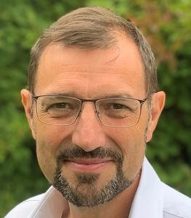 | Catherine Merriman is a Junior Doctor based in London. Along with her family members, she has been a long-standing supporter and volunteer for Hospice Africa.  Catherine first visited Uganda in 2005 and has returned a few times, volunteering at the 3 different sites at Kampala, Mbarara and Hoima. She seeks to use her skills as a doctor working directly with patients, and supporting the positive care and vision of Hospice Africa.
Will Peachey
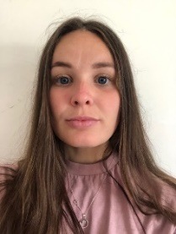
Catherine Merriman

The charity’s work continues to be carried out entirely on a voluntary basis. The Hon. Treasurer manages the day-to-day finances of the charity. The Hon. Chair, Hon. Secretary and Hon. Treasurer, with help from other Trustees, have shared the collective duties normally carried out by a Chief Executive. The Board of Trustees has the power to appoint additional Trustees as it sees fit within the remit of the Articles of Association.

The work is carried out in close partnership with the Founder, Professor Anne Merriman, and there is regular contact with Hospice Africa Uganda (HAU), which is a non-governmental organization and a limited company in Uganda. There is an AGM at the end of September when trustees, donors, supporters and charity shop staff meet at the Brain Charity Centre in Liverpool, with a zoom on-line link available from anywhere globally, but particularly providing links for Trustees and supporters located in Africa.

Hospice Africa Origins

Hospice Africa (HA) was founded in 1993 to spread the ethos and practice of palliative care in Africa. Our founder, Dr. Anne Merriman, has radically changed the provision of care and pain relief for people in Africa with life-limiting illnesses. This has transformed the lives of thousands of patients, improving quality of life for many and supporting patients to have a comfortable and dignified death.

Hospice Africa raises and manages funds in the UK to send to our partners in Africa, particularly in the long-term with Hospice Africa Uganda (HAU). With our partners, we have helped to introduce palliative care to 35 Africa countries. In 20 of these 35 countries, affordable oral morphine, the backbone of all palliative care, is now available for pain relief.

Fundraising

At Hospice Africa UK, we have managed to stay positive and motivated with our vision for ‘palliative care across Africa central to all that we do’.

The two charity shops in Liverpool and Ainsdale have gradually returned to normal following the Covid-19 pandemic. In Liverpool, the weekly takings have now returned to pre-Covid income, and the Ainsdale shop has returned to near normality. We continue to be grateful to our volunteer shop managers who carry a busy workload to keep the shops running effectively, and also to the dedication of all the shop volunteers.

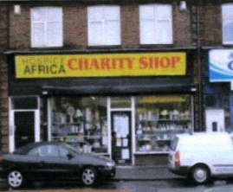 |  | 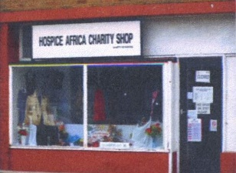
Liverpool Old Swan Shop Ainsdale Shop

One disappointing change that was enforced was to change Hospice Africa UK’s bank account from Allied Irish Bank to Barclays Bank. The Treasurer has carried the brunt of making the administrative changes necessary to change standing orders and to ensure that donor gifts are effectively re-routed. Unfortunately we lost a number of long standing donors due to ‘out of date’ contact information.

New Initiatives

We continue to be grateful for the many supporters who donate monthly to our funds, the majority enabling us to collect Gift Aid. In addition, there are those who donate intermittently when funds allow, and others who support fundraising events including our annual quiz.
Philippa Guppy continued her enthusiasm for the Big Christmas Give, which enables some of the giving in a fixed week in November to be match-funded. Our Big Give Campaign at the end of 2022 produced a Grand Total of £28,207.

A second initiative was highly successful too – London Landmark Legends – where 30 Hospice Africa Runners took part in the Half Marathon to celebrate Hospice Africa turning 30 later in 2023. The total funds raised was over £20,000.

Hospice Africa Uganda

The team in Kampala continue to ensure the provision of specialist palliative care services are offered despite recent challenges. They are so grateful to the Hospice Africa Family, their Uganda Board, and their partners and donors for the unwavering support. During the last year, they have been increasingly able to enrol new patients, and have raised the number to some 50% of previous levels. However, with having to operate with strict budget limitations, it continues to be an ongoing struggle to ensure that the delivery of palliative care services remains viable and sustainable.

An overview of the Hospice Africa work in Uganda is summarised in the Hospice Africa Uganda section of the Website shown below. (www.hospice-africa.org)

Clinical Care | Education | International  Programmes | Morphine  Production
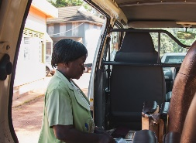 | 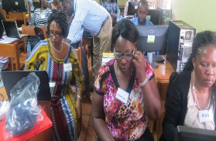 | 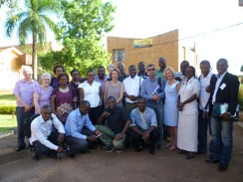 | 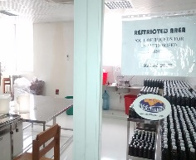
Our clinical teams  treat patients,  providing them with  holistic palliative  care from within the  clinic or at their  homes. They work  from three sites  across Uganda:  Kampala, Hoima  and Mbarara. | A core part of our  mission is to enable  palliative care across  Africa. We do this by  providing training for  students and health-  care professionals  from across the  continent. | Although our clinical  centre is in Uganda,  we work with partner  organisations in  many African  countries to  promote palliative  care across the  continent. | Hospice Africa produces affordable morphine on-site in Kampala which is then prescribed to our patients and send out to other medical facilities across the country.

Give a Chance

Hannah Merriman oversees the ‘Give a Chance’ programme where children of HAU patients have been offered support for their schooling on an ongoing basis. This is a relatively small programme supported by a small number of enthusiastic donors who provide ‘committed’ donations.

Volunteers Travelling to Uganda

There has been an increase in volunteers (doctor, nurse, physiotherapist) from the UK visiting the various sites in Uganda over the last 12 months which has been
hugely supportive for the clinical teams in Uganda.

Dr. Anne Merriman was able to report in the August 2022 Newsletter that, after two difficult years health-wise, she is much better and improving each day.

Brief Financial Review

The charity’s income of the charity increased significantly from £205,932 last year to £298,434, with resources expended increasing from £173,569 last year to £186,035.
The income exceeds expenditure by £112,400 resulting in our reserves increasing from £178,452 last year to £290,852.

Charitable activities amounted to £159,610 supporting work primarily in Uganda and Malawi. They also support the development of palliative care clinicians from other African countries through the educational programmes run by HAU’s Institute (Institute of Hospice and Palliative Care in Africa).

The Board of HAU has continued to manage the running costs with care, but there still remains a challenging funding shortfall in Uganda. There have been regular on-line meetings between the UK Chair and UK Treasurer and HAU senior staff aimed at evaluating the ongoing deficit and trying to ensure that Hospice Africa Ltd can continue to regulate its income, reserves, and budgeted funding to HAU to ensure that HAU remains solvent both in the 2022-23 period and in the immediate years ahead.

Funding Risks

Because the Charity employs no staff, except on a voluntary basis, all of the income raised, apart for a small amount of governance expenditure, is used directly for the work of the Charity in its core objective of palliative care for the African continent. The probity exercised by UK Trustees is to convert the funds already raised in the UK to become available to send to Uganda.

Trustees are aware that there was still a two-fold risk, as the Hospice Africa organisation steered through a difficult year.

- an on-going deficit in Uganda: the HAU Board must bring operations out of deficit.
- a likely reduction in funds available in the UK: this is already challenging HA Limited to exercise probity in its UK support to HAU.

HA UK Trustees will continue, as far as possible, to ensure the enduring vision of palliative care for all in need in Africa continues.

Auditor and Independent Examiner

Roger Hughes has resigned, and we need to appoint a new Accountant. A resolution to appoint a replacement will be made at the Annual General Meeting.
We thank Roger for his work on our behalf over many years.

This report was approved by the Board of Directors and Trustees on 31st July 2023 and signed by  the Hon. Chair, Chris Merriman | 

