HOSPICE AFRICA LIMITED  Report of the Directors & Trustees  for the year ended 31st March 2022 | 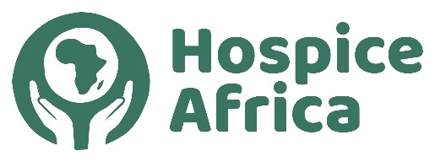

Contents
Legal & Administrative Information 1
Governance & Management – Trustee News 2
Post-Covid Progress – Charity Shops in the UK 3
Fundraising 3
Hospice Africa Uganda 4
Finance & Governance Risks 5
Audited Accounts A1 - A7

Legal and administrative information

Company number:  Registered in England No. 02835469 | Registered charity number:  Charity Commission No. 1024903

Directors and Trustees at 31st March 2022:  Mr. Chris Merriman (Hon. Chair)  Ms. Pat Linnell (Hon. Treasurer)  Dr. Mary Bunn (Hon. Secretary)  Prof. Anne Merriman (Founder) MBE | Mr. Doug Haynes  Ms. Hannah Merriman  Dr. Philippa Guppy  Dr. Ged Faulks - Resigned 26/09/2021

Company Secretary: Dr. Mary Bunn | Independent Examiner: Roger Hughes
Registered Office:  Holly Bank, 34 Altys Lane,  Ormskirk. L39 4RQ | Lower Farm  90 Brimstage Road, Heswall,  Wirral. CH60 1XQ

REPORT OF THE DIRECTORS AND TRUSTEES

The Trustees, who are also the Directors of the charity for the purposes of the Companies Act, present their annual report and the financial statements for the year ended 31 March 2022. The Trustees have adopted the provisions of the Statement of Recommended Practice (SORP 2005) "Accounting and Reporting by Charities" in preparing the annual report and financial statements of the charity.

The AGM 2022 has been scheduled to be in person at The Brain Centre (Norton St, Liverpool L3 8LR ) on Sunday 25th September 2022 at 2pm. We are hoping to arrange an on-line link into the Business Meeting, and subsequent Briefings.

Structure, Governance and Management

The charity is constituted as a company limited by guarantee, governed by a memorandum and articles of association. The charity’s object and principal activity continues to be “to provide and support the provision of palliative care to terminally ill cancer and AIDS patients and their families in the African setting”.

The Trustees have continued to meet regularly to manage the affairs of the charity in the UK. The zoom platform has been transformational in reducing a very significant amount of travel in the UK and enabling Trustees Dr. Anne Merriman and Dr. Mary Bunn to attend from Africa!

We would like to give our grateful thanks for the huge contribution given to the work of Hospice Africa by retiring Trustee, Ged Faulks. Having worked early on as an SHO with Dr. Anne at Whiston hospital in the 1970s, Ged has been a tireless and generous supporter. He has been Trustee Chair for 3 years, provided much wisdom from his GP background, and been a great team player. | 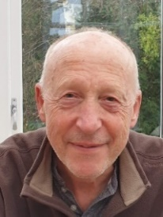

We are grateful to Canon Dr. Donald Gray and Frank Cottrell-Boyce who have kindly acted as Patrons for Hospice Africa.

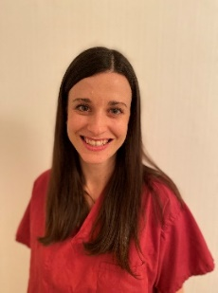 | We have been delighted to welcome Dr Philippa Guppy, who is a palliative care doctor and senior lecturer working in London, as a new Trustee. She first visited Uganda in 2019 to volunteer for Hospice Africa in Kampala. She was inspired by the hospice team and by Dr. Anne in equal measure, and she has been a firm supporter ever since. Philippa has brought enthusiasm for fund raising since working in the palliative care field, and living in London, she has many opportunities to promote and investigate various sources of funding.

The Charity’s work continues to be carried out entirely on a voluntary basis. The Honorary Treasurer manages the day-to-day finances of the charity. The Hon. Chair, Hon. Secretary and Hon. Treasurer, with help from other Trustees, have shared the collective duties normally carried out by a Chief Executive. The Board of Trustees has the power to appoint additional Trustees as it sees fit within the remit of the Articles of Association.

The work is carried out in close partnership with the Founder, Professor Anne Merriman, and there is regular contact with Hospice Africa Uganda (HAU), which is a non-governmental organization and a limited company in Uganda. There is an AGM at the end of September when Trustees, donors, supporters and Charity Shop staff meet at the Brain Charity Centre in Liverpool.

Hospice Africa Origins

Hospice Africa (HA) was founded in 1993 to spread the ethos and practice of palliative care in Africa. Our founder, Dr. Anne Merriman, has radically changed the provision of care and pain relief for people in Africa with life-limiting illnesses. This has transformed the lives of thousands of patients, providing significantly longer life for many and allowing others a pain-free and dignified death.

Hospice Africa raises and manages funds in the UK to send out to our partners in Africa, particularly in the long-term with Hospice Africa Uganda (HAU). With our partners, we have helped to introduce palliative care to 35 Africa countries. In 20 of these 35 countries, affordable oral morphine, the backbone of all palliative care, is now available for pain relief.

POST-COVID PROGRESS

We reported in our Christmas Newsletter 2021, ‘What another crazy year it has been! At Hospice Africa UK, we have been faced with a lot of challenges, alongside the changes that Covid has brought, but we have managed to stay positive and motivated with our vision for palliative care across Africa central to all that we do.’

The two charity shops in Liverpool and Ainsdale have gradually returned to normal working, where those who seek extra safety from the virus, volunteer staff or shoppers, protect themselves by wearing masks. In Liverpool, the weekly takings have now returned to pre-Covid income, and the Ainsdale shop has returned to near normality. We continue to be grateful to our managers and volunteers who carry a busy workload to keep the shops running effectively.

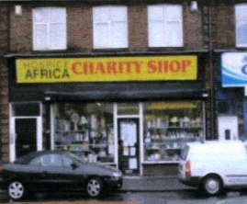 |  | 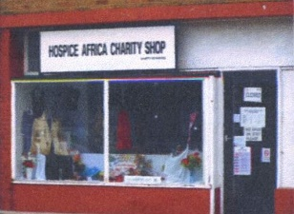
Liverpool Old Swan Shop Ainsdale Shop

Fundraising

We continue to be grateful for the many supporters who donate monthly to our Hospice Africa funds, the majority enabling us to collect Gift Aid. In addition, there are those who are able to donate intermittently when funds allow, and others who join our on-line quizes or special events. An example in June 2021 was one of our Hospice friends, Dr. David Smithard, who cycled 1,000 miles, with his two sons, from John O’Groats to Lands End.

Our new Trustee, Philippa Guppy, introduced us to a new initiative called the Big Christmas Give 2022, which enables some of the giving in a fixed week in November to be matched. £15,483 was raised, including Gift Aid, and 36% of the donations were matched. We intend to continue this initiative as we approach Christmas 2022.

Hospice Africa Uganda

The team in Kampala continue to ensure that dedicated palliative care services are offered amidst the challenges. They are so grateful to the Hospice Africa Family, their Uganda Board, and their partners and donors for the unwavering support. Covid-19 has been very hard hitting in Uganda with reduced travel options, increased travel costs, and the earlier strict lockdown rules have meant that patient numbers decreased dramatically. However, during the last year, they have been increasingly able to enrol new patients again, and raised the number to some 50% of previous levels. However with strict budget limitations, it is looking like a tough road ahead.

An overview of the Hospice Africa Work in Uganda is summarised on the Hospice Africa Uganda section of the Website in the following way.

Clinical Care | Education | International  Programmes | Morphine  Production
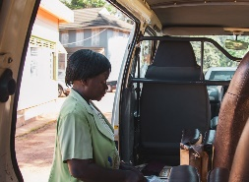 | 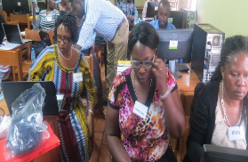 | 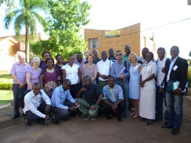 | 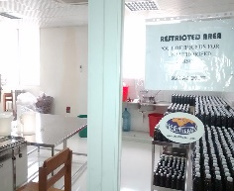
Our clinical teams  treat patients,  providing them with  holistic palliative  care from within the  clinic or at their  homes. They work  from three sites  across Uganda:  Kampala, Hoima  and Mbarara. | A core part of our  mission is to enable  palliative care across  Africa. We do this by  providing training for  students and health-  care professionals  from across the  continent. | Although our clinical  centre is in Uganda,  we work with partner  organisations in  many African to  promote palliative  care across the  continent. | Hospice Africa produces affordable morphine on-site in Kampala which is then prescribed to our patients and send out to other medical facilities across the country.

It has been good news to hear that the Daycare Service has resumed. This is a service provided at the hospice site where patients and families can come together to eat, be social, and try out different crafts; the service is for both adults and children at HAU.

Please join us in celebrating Dr. Eddie Mwebesa, who is the winner of the International Association for Hospice and Palliative Care Individual Recognition Award. The award recognises his outstanding dedication to the development and provision of palliative care, leading to improvements in the quality of life of patients with serious health-related suffering. | 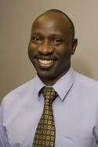

Hospice in Grief – Tom Duku

Our August 2021 Newsletter reported the death of the Chair of the Ugandan Board (Hospice Africa Uganda) Tom Duku, who sadly died last year from Covid, bringing shock and grief to the whole of the HAU Team. He touched many lives.  He came to HAU as a young man, having completed a course in ethical accounting in 1995.  He played an important role in steering the financial challenges that the Hospice faced over the last few years. Tom will be truly missed; we are truly grateful for Tom’s dedication and commitment to HAU and his steering role in the last few years. May he rest in peace. | 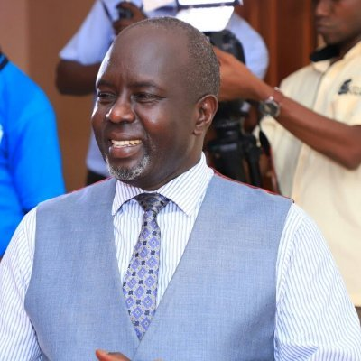  Tom Duku

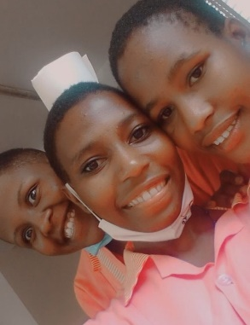 | Give a Chance: Josephine Nakamjajo had been on the Give a Chance programme since she was in primary school. She became an orphan after her mother died of cancer on the hospital programme, and her schooling was funded by Give a Chance. She has began her training as a nurse, is happy and grateful for the support she has had, and we know that she will make a brilliant nurse one day!

Brief Financial Review

Income of the charity reduced marginally from £208,075 last year to £205,932, with resources expended increasing from £140,299 last year to £173.570. Charitable activities totalled £152,371 supporting work primarily in Uganda and Malawi. The income exceeds expenditure by £32,362 resulting in our reserves increasing from £146,090 last year to £178,452.

The Board of Hospice Africa Uganda has continued to try and keep the running costs under control, but there still remains a challenging funding shortfall. In the UK, Hospice Africa Ltd has been using its income and reserves to ensure HAU remains solvent in the 2021-22 period.

Funding Risks

Because the Charity employs no staff, except on a voluntary basis, all of the income raised, apart from a small amount of governance expenditure, is used directly for the work of the Charity on its core objective of palliative care on the African continent. The probity exercised by UK Trustees is to convert the funds already raised in the UK to become available to send to Africa. Currently, the major focus has been to send budgeted funding to Uganda, and in a few cases, some emergency funding more widely in Africa.

Trustees are aware that there is a two-fold risk, amplified by the effects of the Covid19 virus, as the Hospice Africa organisation steered through a difficult year.
- an on-going deficit in Uganda: the HAU Board must bring operations out of deficit.
- a likely reduction in funds available in the UK: this is already challenging HAUK to exercise probity in its UK support to HAU, as near as possible to the previous funding levels. UK Trustees are now working closely and regularly with the HAU Board to try and ensure HAU continues to be viable for the patients in Uganda, in the current and future years ahead. HA UK will continue, as far as possible, to ensure the enduring vision of palliative care for all in need in Africa.

Auditor and Independent Examiner

A resolution proposing that ‘Roger Hughes, Chartered Accountant, be reappointed as the charity’s Independent Examiner’ will be put to the Annual General Meeting.

This report was approved by the Board of Directors and Trustees on 23rd August 2022 and signed by  the Hon. Chair, Chris Merriman | 

